# Actors

**Sales Assistant**

Sales Assistant is a person who is responsible of managing customer and customer site information. If there are needs on managing customer’s information or customer site, creating, updating and marking for deletion. Sales person makes those necessary changes or marking for deletion, but all those changes need to be confirmed by authorized sales assistant.

**Sales Planning**

Sub-system; according to specific customer, sales’ planning is going to use information from customers for setting up discount rates and etc.

**Order Processing**

Sub-system which is going to use existing customers and customer sites information.

# Services

**Registering new customer/ customer site**

**Updating customer/customer site**

**Confirm customer/customer site update**

**Mark customer/customer site to be deleted**

**Display customer/ customer site information**

# Use Cases

**Diagram:**

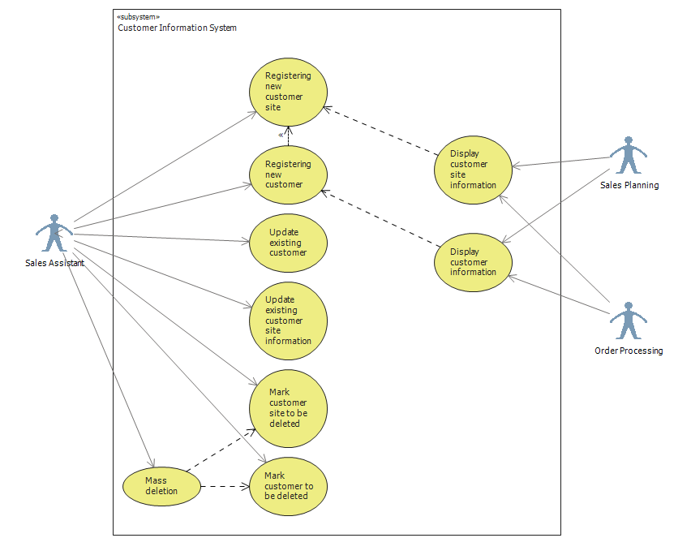

**Descriptions:**

|  |  |
| --- | --- |
| **Use Case** | **Registering new customer** |
| **Actor:** | Sales assistant |
| **Pre-condition:** | Customer wants to have permanent registration in Lahjapaja system or Lahjapaja contacts potential customer;  Sales assistant logged into the system.  Information about company’s creditability is checked by some responsible employee |
| **Goal:** | New customer is stored in the database and has a unique identifier. |
| 1 | Sales assistant press new customer button |
| **2** | System generates new customer ID number |
| **3** | Sales Assistant inserts company name |
| **4** | Sales Assistant fills/chooses invoicing address – town, postal number, street, house number. |
| **5** | Sales Assistant fills/chooses visiting address – town, postal number, street, house number |
| **6** | Sales Assistant fills contact person information - name, tel. number, email, address. |
| **7** | Sales Assistant fills contract information – creditability, terms of delivery, terms of payment, credit limit and disc. rate |
| **8** | Sales Assistant chooses the Customer Group information |
| **9** | Sales Assistant chooses the appropriate Status information |
| **10** | Sales Assistant presses Save button |
| **11** | System saves records in Address table, Contract table, Contact Person table, Customer table, Group table along with their unique IDs and automatically creates the Customer Site record . |
| **12** | New customer is stored in the system's database. |

|  |  |
| --- | --- |
| **Use Case** | **Registering new customer site** |
| **Actor:** | Sales assistant |
| **Pre-condition:** | Customer site will contact LahjaPaja or Lahjapaja will contact the customer;  Basic customer information is stored in the system;  Sales Assistant is logged in the system  Sales Assistant and Register Customer page or Display customer page is opened in front of him/her ; |
| **Goal:** | New Customer site is stored to the database and has unique Customer site number |
| 1 | Sales assistant press new customer site button on Register/ Update customer page or Display Customer page. |
| 2 | System generates new customer site ID number |
| 3 | Sales Assistant will choose the Customer ID, which the site will be attached to. |
| 4 | Sales Assistant will fill Customer Site name |
| 5 | System will automatically fill Sales initial value as 0 (will be prefilled by other subsystem), date of the last sale (will be prefilled by other subsystem). |
| 6 | Sales Assistant will fill delivery address – town, postal number, street, house number |
| 7 | Sales Assistant will fill the postal address |
| 8 | Sales Assistant will fill contact person information - name, tel. number, email, address. |
| 9 | Sales Assistant will select Contract ID |
| 10 | Sales Assistant will select appropriate Status information |
| 11 | Sales Assistant presses Save button |
| 12 | New Customer site is stored into the system ‘s database |

|  |  |
| --- | --- |
| **Use Case** | **Update existing customer** |
| **Actor:** | Sales assistant |
| **Pre-condition:** | Customer or someone in house notifies of changes or errors in stored data  Sales Assistant Logged in the system  Display customer page is opened in front of him/her ; |
| **Goal:** | Updating of data in the system |
| 1 | Sales assistant selects existing customer on Register/ Update customer page or Display Customer page. |
| 2 | Press Update Customer Button. |
| 3 | System retrieves information about customer, with filled data about it. |
| 4 | Sales assistant alters one, several or all existing fields:  Customer name, invoicing address, visiting address, contact person fields, contract information fields (creditability, terms of delivery, terms of payment, credit limit and disc. rate) |
| 5 | Sales Assistant chooses different Customer Group if needed on Update Customer page |
| 6 | Sales Assistant chooses the appropriate Status information on Update Customer page |
| 7 | Sales assistant presses Save button on Update Customer information. |
| 8 | Updated Customer is stored into the system ‘s database |

|  |  |
| --- | --- |
| **Use Case** | **Update existing customer site information** |
| **Actor:** | Sales assistant |
| **Pre-condition:** | Customer or someone in house notifies of changes or errors in stored data  Sales assistant logged in;  Display customer page is opened in front of him/her ; |
| **Goal:** | The existing information about customer site is updated and stored in the system |
| 1 | Sales Assistant selects the desired Customer Site by its name or ID |
| 2 | Sales assistant press update customer site button on Register/ Update customer page or Display Customer page. |
| 3 | System retrieves information about customer site, with filled data about it. |
| 4 | Sales assistant alters one, several or all existing fields:  Customer site name, delivery address fields, postal address fields, contact person fields, contract information fields |
| 5 | Sales Assistant chooses different Customer Group if needed on Update Customer site page |
| 6 | Sales Assistant chooses the appropriate Status information on Update Customer site page |
| 7 | Sales assistant presses Save button on Update Customer site page. |
| 8 | Updated Customer site information is stored into the system ‘s database |

|  |  |
| --- | --- |
| **Use Case** | **Mark customer site to be deleted** |
| **Actor:** | Sales assistant |
| **Pre-condition:** | Particular customer site is not needed in the system anymore  Lahjapaja’s decision to delete  Sales assistant logged in;  Opened Display Customer; |
| **Goal:** | The existing information about customer site is marked to be deleted from system |
| **1** | Sales Assistant selects the desire Customer site by its name or ID |
| **2** | Sales Assistant presses Update Customer site button |
| **3** | The Update Customer Site page will open with prefilled data fields |
| **4** | Sales Assistant changes Status to marked to be deleted. |
| **5** | The system will prompt the user again, if s/he is sure |
| **6** | Press Save Button to apply the changes |
| **7** | Customer site will wait for mass deletion process. |

|  |  |
| --- | --- |
| **Use Case** | **Mark customer to be deleted** |
| **Actor:** | Authorized Sales assistant |
| **Pre-condition:** | Customer is not interested anymore in business;  Lahjapaja’s decision to delete;  Sales assistant logged in;  Opened Display Customer; |
| **Goal:** | The existing information about customer is marked to be deleted from the system |
| **1** | Sales Assistant selects needed Customer by its name or ID |
| **2** | Checks if customer has any sites more (by system) |
| **3** | The Update Customer page will open with prefilled data fields |
| **4** | Sales Assistant changes Status to marked to be deleted. |
| **5** | The system will prompt the user again, if s/he is sure to mark for the deletion. |
| **6** | Press Save Button to apply the changes |

|  |  |
| --- | --- |
| **Use Case** | **Mass deletion** |
| **Actor:** | Sales Assistant with special permission |
| **Pre-condition:** | Certain customer or customer sites were marked for deletion by some sales assistant  Sales Assistant logged in as the actor with special permission;  Display customer page is open and list of marked customer or sites is available; |
| **Goal:** | The existing information about customer or site is deleted from the system |
| **1** | Responsible actor filters the customers or sites by status (marked to be deleted) |
| 2 | Press Mass Delete Button |
| 3 | Confirmation window will appear |
| **4** | Confirm Deletion |

|  |  |
| --- | --- |
| **Use Case** | **Display Customer information by Sales Assistant** |
| **Actor:** | Sales Assistant |
| **Pre-condition:** | Sales Assistant logged in as the actor with special permission and sees all information  Main Page is open and list of customers is available; |
| **Goal:** | The existing information about customer are to be filtered according to key |
| **1** | Responsible actor filters the customers by key in datatable |
| 2 | System selects the matching records from the database |

|  |  |
| --- | --- |
| **Use Case** | **Display Customer Site information by Sales Assistant** |
| **Actor:** | Sales Assistant |
| **Pre-condition:** | Sales Assistant logged in as the actor with special permission and sees all information  Main Page is open and list of customer sites is available; |
| **Goal:** | The existing information about customer sites is to be filtered according to key |
|  | **Scenario number one – User selects the customer site by the key** |
| 1 | Responsible actor filters the customer sites by key in data table |
| 2 | System selects the matching records from the data base |
|  | **Scenario number two – User selects the customer by its key in one datatable and in the second datatable the list of Customer Sites will be filtered according to the Customer key** |
| 1 | Selects the Customer in datatable by the key |
| 2 | System filters the Customer Site datatable |

|  |  |
| --- | --- |
| **Use Case** | **Display customer information by other subsystems** |
| **Actor:** | Sales Planning subsystem/Order processing subsystem |
| **Pre-condition:** | There is a need in utilizing customer information.  Customers’ information is stored in the system and is available to be displayed.  The actor has access to the database tables with information about customer or/and customer sites. |
| **Goal:** | The acquired information about a customer is utilized. |
| **1** | The actor selects a customer according to the actor’s needs. |
| **2** | The customer information is displayed on the screen: company name, invoicing and delivery address, contact person information, way of delivery and other possible information based on the UI of the subsystem. |

|  |  |
| --- | --- |
| **Use Case** | **Display customer site information by other subsystems** |
| **Actor:** | Sales Planning subsystem/Order processing subsystem |
| **Pre-condition:** | There is a need in utilizing customer site information. Customer sites’ information is stored in the system and is available to be displayed.  The actor has access to the database tables with information about customer or/and customer sites. |
| **Goal:** | The acquired information about a customer site is utilized according to particular actor’s requirements. |
| **1** | The actor selects a customer site according to corresponding subsystem architecture and the actor’s needs. |
| **2** | The customer site information is displayed on the screen: company name, invoicing and delivery address, contact person information, way of delivery and other possible information based on the UI of the subsystem. |
| **3** | The actor chooses the desired information and processes it according to corresponding subsystem needs. |